**FICHE - Apprentissage**

# 

**IO = Input et Output**

**INPUT**

Identifiez l'input précis (format informatique et mathématique) de l'algorithme et de chaque module. Donnez un exemple SVP !

Format XML, en 1D et utilisation de label map.

**OUTPUT**

Identifiez l'output précis de votre apprentissage. Donnez un exemple SVP !

Image Format JPG , 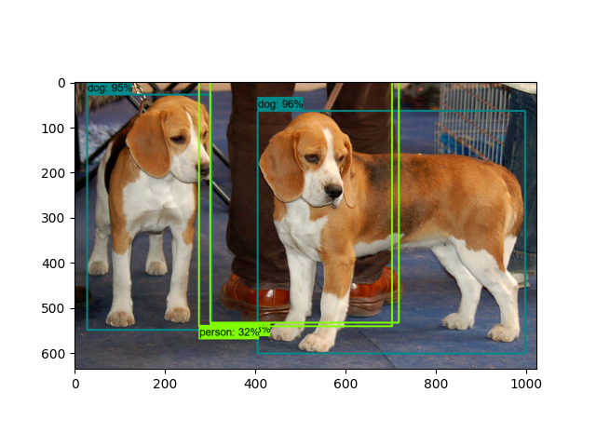

**ORITHMENNÉ**

**OPTIMISATION**

Que tente d'optimiser votre algorithme, d'un point de vue données brutes (mathématique)

* Est-ce une erreur entre une valeur désirée et une valeur obtenue ? Si oui laquelle ?
* Est-ce une fonction d'évaluation est utilisée ? Si oui quelle est-elle ?|

TotalLoss prévu de minimum 2 et le mieux serait de 1 ou moins.

**ALGORITHME**

# ÉTAPES de l'ALGORITHME

**Décrivez votre algorithme en étapes détaillées (rétropropagation, évolution ou autre).**

1. **Extraction des feature**
2. **initialisation**
3. **Activation RELU_ 6**
4. **Box coder**
5. **matcher**
6. **Box predictor**
7. **Anchor generator**
8. **Post processing**
9. **Analyse des loss**
10. **Training en tant que tel**

# ILLUSTRATION de l'ALGORITHME

Illustrez l'algorithme (couches convolutives, mutations, etc.)



**CODE**

# CONSTRUCTION

# Donnez le code de construction de votre structure d'apprentissage

# 

1 model {

2 ssd {

3 num_classes: 1 *# Set this to the number of different label classes*

4 image_resizer {

5 fixed_shape_resizer {

6 height: 640

7 width: 640

8 }

9 }

10 feature_extractor {

11 type: "ssd_resnet50_v1_fpn_keras"

12 depth_multiplier: 1.0

13 min_depth: 16

14 conv_hyperparams {

15 regularizer {

16 l2_regularizer {

17 weight: 0.00039999998989515007

18 }

19 }

20 initializer {

21 truncated_normal_initializer {

22 mean: 0.0

23 stddev: 0.029999999329447746

24 }

25 }

26 activation: RELU_6

27 batch_norm {

28 decay: 0.996999979019165

29 scale: true

30 epsilon: 0.0010000000474974513

31 }

32 }

33 override_base_feature_extractor_hyperparams: true

34 fpn {

35 min_level: 3

36 max_level: 7

37 }

38 }

39 box_coder {

40 faster_rcnn_box_coder {

41 y_scale: 10.0

42 x_scale: 10.0

43 height_scale: 5.0

44 width_scale: 5.0

45 }

46 }

47 matcher {

48 argmax_matcher {

49 matched_threshold: 0.5

50 unmatched_threshold: 0.5

51 ignore_thresholds: false

52 negatives_lower_than_unmatched: true

53 force_match_for_each_row: true

54 use_matmul_gather: true

55 }

56 }

57 similarity_calculator {

58 iou_similarity {

59 }

60 }

61 box_predictor {

62 weight_shared_convolutional_box_predictor {

63 conv_hyperparams {

64 regularizer {

65 l2_regularizer {

66 weight: 0.00039999998989515007

67 }

68 }

69 initializer {

70 random_normal_initializer {

71 mean: 0.0

72 stddev: 0.009999999776482582

73 }

74 }

75 activation: RELU_6

76 batch_norm {

77 decay: 0.996999979019165

78 scale: true

79 epsilon: 0.0010000000474974513

80 }

81 }

82 depth: 256

83 num_layers_before_predictor: 4

84 kernel_size: 3

85 class_prediction_bias_init: -4.599999904632568

86 }

87 }

88 anchor_generator {

89 multiscale_anchor_generator {

90 min_level: 3

91 max_level: 7

92 anchor_scale: 4.0

93 aspect_ratios: 1.0

94 aspect_ratios: 2.0

95 aspect_ratios: 0.5

96 scales_per_octave: 2

97 }

98 }

99 post_processing {

100 batch_non_max_suppression {

101 score_threshold: 9.99999993922529e-09

102 iou_threshold: 0.6000000238418579

103 max_detections_per_class: 100

104 max_total_detections: 100

105 use_static_shapes: false

106 }

107 score_converter: SIGMOID

108 }

109 normalize_loss_by_num_matches: true

110 loss {

111 localization_loss {

112 weighted_smooth_l1 {

113 }

114 }

115 classification_loss {

116 weighted_sigmoid_focal {

117 gamma: 2.0

118 alpha: 0.25

119 }

120 }

121 classification_weight: 1.0

122 localization_weight: 1.0

123 }

124 encode_background_as_zeros: true

125 normalize_loc_loss_by_codesize: true

126 inplace_batchnorm_update: true

127 freeze_batchnorm: false

128 }

129}

130train_config {

131 batch_size: 8 *# Increase/Decrease this value depending on the available memory (Higher values require more memory and vice-versa)*

132 data_augmentation_options {

133 random_horizontal_flip {

134 }

135 }

136 data_augmentation_options {

137 random_crop_image {

138 min_object_covered: 0.0

139 min_aspect_ratio: 0.75

140 max_aspect_ratio: 3.0

141 min_area: 0.75

142 max_area: 1.0

143 overlap_thresh: 0.0

144 }

145 }

146 sync_replicas: true

147 optimizer {

148 momentum_optimizer {

149 learning_rate {

150 cosine_decay_learning_rate {

151 learning_rate_base: 0.03999999910593033

152 total_steps: 25000

153 warmup_learning_rate: 0.013333000242710114

154 warmup_steps: 2000

155 }

156 }

157 momentum_optimizer_value: 0.8999999761581421

158 }

159 use_moving_average: false

160 }

161 fine_tune_checkpoint: "pre-trained-models/ssd_resnet50_v1_fpn_640x640_coco17_tpu-8/checkpoint/ckpt-0" *# Path to checkpoint of pre-trained model*

162 num_steps: 25000

163 startup_delay_steps: 0.0

164 replicas_to_aggregate: 8

165 max_number_of_boxes: 100

166 unpad_groundtruth_tensors: false

167 fine_tune_checkpoint_type: "detection" *# Set this to "detection" since we want to be training the full detection model*

168 use_bfloat16: false *# Set this to false if you are not training on a TPU*

169 fine_tune_checkpoint_version: V2

170}

171train_input_reader {

172 label_map_path: "annotations/label_map.pbtxt" *# Path to label map file*

173 tf_record_input_reader {

174 input_path: "annotations/train.record" *# Path to training TFRecord file*

175 }

176}

177eval_config {

178 metrics_set: "coco_detection_metrics"

179 use_moving_averages: false

180}

181eval_input_reader {

182 label_map_path: "annotations/label_map.pbtxt" *# Path to label map file*

183 shuffle: false

184 num_epochs: 1

185 tf_record_input_reader {

186 input_path: "annotations/test.record" *# Path to testing TFRecord*

187 }

188}

# 

# 

# EXÉCUTION

# Donnez le code qui lance l'exécution de l'apprentissage dans votre technologie

python model_main_tf2.py --model_dir=models/my_ssd_resnet50_v1_fpn --pipeline_config_path=models/my_ssd_resnet50_v1_fpn/pipeline.config